
5/28/2024
Evaluation Report
Spotify Music Data

Submitted By:
Elijah Shepherd

Submitted To:
Aspiring Musician

Introduction
Background: Your friend, who is an aspiring musician, wants to make a hit song and has asked you to use your data skills to help her. You have decided to analyze what makes a top song, keeping in mind changes over the years. What concrete recommendations can you give her before she writes lyrics, makes beats, and records the song? She's open to any genre.
Purpose: The project associated with this report used data consisting of music that was among the most popular "hit" (or top) songs according to the standards of the Billboard between 2010 & 2019. The dataset included information about songs such as the artist, genre, & several numerical parameters used to help describe the song in quantitative ways. Objectives of the analysis included:
- Identify how the parameters in the data relate to a song's popularity – quantified in the dataset via the 'pop' parameter.
- Identify the most popular music in the dataset & analyze how the parameters of this music relate to these songs' popularity.
- Determine values for each of the parameters of a song based on the analyses of these parameters for the most popular music. These values will be used as recommendations for the aspiring artist to use to create their own music in the hopes that it will be popular (or a "hit").
The projections, recommendations, & relevant analysis are to be provided to the aspiring artist.
The Data: The data used in this report & project pertained to popular music as measured & identified by the Billboard. The dataset, which spanned from 2010 to 2019, included information that described & quantified each song. There are 603 observations & 14 different variables for each observation. There are no missing values in the dataset.
The parameters in the dataset included each song's title, artist, genre, & other numerical parameters that quantitatively describe each song which included: beats per minute (the tempo of the song), energy, danceability (higher values mean it's easier to dance to), decibels (loudness of the song), liveness (likeliness the song was recorded with a live audience), valence (higher values mean a more positive/happy/cheerful sound), duration, acousticness, speechiness (higher values mean more spoken words/lyrics), & popularity. All these numerical parameters have integer values.
For context, the Billboard is an "American music and entertainment magazine published weekly by the Penske Media Corporation. The magazine provides music charts, news, video, opinion, reviews, events and styles related to the music industry" (Google). Among many different tasks & operations, the Billboard tracks the most popular music across various musical genres. As such, it is important to note that even though the music in the dataset provided was assessed & quantified by a reputable & longstanding business within the music industry, the popularity of the music can be argued as subjective because there are various definitions as to what makes a song popular. The dataset does not define how the 'pop' parameter was measured, nor does it explain what makes a song "popular." This concept is important for the purposes of this report because the analysis attempts to quantify what characteristics of a song make it "popular." In other words, what characteristics of a song help to produce a high 'pop' value.
There were some instances of duplicate songs in the data; however, upon further investigation, all but one of these duplicates weren't "true" duplicates. Essentially, there were 16 songs that were in the dataset multiple times, but 15 of them had two different 'year' values. This was interpreted to mean that these songs made the Billboard twice, which could imply that these songs were popular enough to make the Billboard twice. Of course, this implication assumes that there weren't any entry errors when this dataset was made & imported. The 'year' parameter was the only value that differed for each of these 15 duplicates. As such, these duplicated songs weren't adjusted in any way.
The other duplicate song, "Sugar" by Maroon 5, was different in that it had the same 'year' value in both instances, the only difference being the value for the 'pop' (popularity) parameter. As such, "Sugar's" 'pop' was changed to reflect the average 'pop' of the two duplicates, & then one of these duplicates was dropped from the dataset. After cleaning up these instances of duplication, the dataset had 602 songs.
Additionally, when inspecting & cleaning the dataset before any analysis, one song was found to have several strange values. These unusual values were searched for by analyzing the ranges of each of the numerical parameters, determining outliers, & inspecting songs with values that stood out in relation to these statistics. The song "Million Years Ago" by Adele had several strange values that stood out even from other outliers. For example, the 'bpm' value was zero; such a tempo would imply that the song is constant for its entire length, or the song must have a tempo so small that it was rounded to zero. Moreover, the 'spch' parameter had a value of zero. By listening to the song online, some of these values can be verified, such as the duration of the song ('dur'). On the other hand, listening to the song made it clear that some of the values for this song were incorrect, specifically 'bpm' & 'spch.' There are clearly spoken words in the song.
As such, it was clear that some of the values for this song were incorrect & needed to be adjusted. Fortunately, the artist of this song, Adele, had ten total songs in the dataset. The average values of each numerical parameter of Adele's music (excluding "Million Years Ago") were calculated & imputed into the song "Million Years Ago." This changed the following variables of this song: 'bpm', 'nrgy', 'dnce', 'dB', 'live', 'val', 'acous', 'spch', & 'pop.'
Analysis
The Analysis: In the project (python notebook), the relevant section for this report is in Analysis IV, which is just over two-thirds of the way into the notebook.
The first objective of the analysis was to identify how the parameters in the data related to a song's popularity. By a "hit" or "top song," the analysis assumed this to mean music with a high 'pop' value. For this dataset, all the parameters can be analyzed apart from 'year'; however, 'pop' can still be analyzed with respect to 'year' to understand how 'pop' evolved over time in the dataset. Previous analyses of 'pop' from other sections in the project (specifically Analysis I & II) could be used for such purposes – these sections included analyses of the most popular artists & genres, & how numerical parameters changed over time.
Multiple tools & methods can help provide recommendations for the aspiring musician. For example, heatmaps that incorporate correlation coefficients of different parameters would illustrate how different variables are related to 'pop.' In the Analysis I section, the most popular artists & genres were determined. By filtering the data for these specific artists and/or genres, the most popular music can be analyzed to determine how the parameters of these artists' & genres' music are constructed.
Using standards outlined by the National Institute of Health (NIH), the correlation coefficients in the heatmaps were quantitatively described. These standards are listed as follows:
- Coefficients with magnitude < 0.30: Negligible correlation
- Coefficients with magnitude 0.30 < 0.50: Low correlation
- Coefficients with magnitude 0.50 < 0.70: Moderate correlation
- Coefficients with magnitude 0.70 < 0.90: High correlation
- Coefficients with magnitude 0.90 < 1.00: Very high correlation
Heatmaps were produced to analyze relationships between numerical parameters & 'pop'. Multiple heatmaps were made using the entire dataset & splitting the data by 'year.' By producing heatmaps for each year of the data, the changes in the relationships between 'pop' & each numerical parameter could be analyzed. These changes are valuable because ideas of what makes a song popular can change & evolve over time. For example, cultural factors may change, technology used to produce music can change, the music industry could change, et cetera. Analyzing these changes will help in understanding how these parameters of popular music may behave & evolve to be able to account for & predict such changes when projecting characteristics of popular music in the future. Additionally, analyses of recent behaviors of these parameters are more relevant to the objectives of this analysis in wanting to project values of a song's characteristics for the aspiring musician.
When splitting the data & conducting analyses on subsets of data such as yearly subsets, it was important to recognize that there were differing numbers of songs for each such subset in the dataset. For example, for years with fewer songs, analyses would be less representative because outliers have a greater potential of influencing calculations & conclusions. For years with greater numbers of songs, potential influences of outliers will be more diluted because there is more data, thus making any calculations & results more representative. This factor was kept in mind throughout the analysis.
Using heatmaps & other aggregate calculations of the correlations between each parameter & 'pop,' summaries were made to describe each relationship & how they changed over time.
From a previous section of analysis in the project, the most popular artists & genres were identified. The process involved subjectively ranking each artist & genre using the number of songs they had in the dataset & calculations regarding the popularity values of all their songs (i.e. average, standard deviation, minimum, maximum, et cetera). Artists & genres with songs that had larger 'pop' values, 'pop' values with less variance, & more songs were ranked higher. These artists & genres were used in the Analysis IV section of the project as a filter to select some of the most popular music in the dataset. Ultimately, the union of the music of these artists & genres was used for further analysis; the songs corresponding to either the artists or genres at hand. There were 133 songs that made up this filtered dataset. Though this dataset accounted for the most popular artists & genres, it did not eliminate all songs that were less popular. As such, a filter for 'pop' was applied. Specifically, songs with a 'pop' value of at least 65 were selected. This reduced the number of songs from 133 to 127.
An additional heatmap was constructed using this filtered dataset to determine if this approach was appropriate. This was measured by evaluating how much the correlation coefficients between each parameter & 'pop' changed from the entire dataset to this filtered one.
Earlier in the report, duplicate songs were mentioned as a potential set of popular data which could be analyzed for the purposes of this report. The premise was that these 15 songs (each had one duplicate) were popular enough to where they made the Billboard in multiple years. Of these 15 songs, seven of them were among the 133 songs in the previously mentioned dataset. Another heatmap was made for these 15 songs, but yearly heatmaps weren't used because there were too few songs to form representative enough conclusions from.
At this point, the findings from each form of analysis were compiled. This included conclusions of analyses from the most recent data (2017-2019), of yearly correlations between 'pop' & other numerical parameters, & of the duplicated songs. With the results of all these analyses in mind, the third & final objective could be dealt with. More specifically, values of parameters for each song could be calculated & projected to be used as recommendations for the aspiring musician wanting to create their own popular music.
Quantifying the Analyses & Producing Recommendations
The technique that was used to quantify the findings of the analyses & project values for the numerical parameters involved the concept of percentage change. Essentially, values of numerical variables are analyzed to measure how they change over time. By calculating these changes, future values can be projected. When projecting characteristics of future music, it is important to account for how popular music has changed recently because it provides the most relevant data for how music might look & sound in the future, specifically in the immediate. It is illogical to use data from the 1970s to project how music might be like in the 2020s. Therefore, given that the data provides music from 2010-2019, it would not be reasonable to try & project the parameters beyond about 2030. Unfortunately, the most recent data is from 2019 which was a handful of years prior to this analysis, so there likely would have been changes regarding constitutes popular music since 2019 that aren't accounted for & reflected in the data. An important question regarding these projections involves what span of data should be selected. There needs to be enough years of data to create projections from representative trends, but too much data could dilute any such trends & findings. As such, only data from 2017, 2018, & 2019 was used to calculate the projections.
It is important to note that many other methods could be used in this scenario such as making small tweaks to the percentage-change method, using weighted averages, or involving some machine learning algorithm such as a regression technique.
The formula for calculating the percentage change is shown below. $C$ is the percentage change (as a percent), $x_{1}$ is the initial value, & $x_{2}$ is the final value.
$$C= \frac{x_{2}-x_{1}}{x_{1}}*100$$
Additionally, a cutoff value was again used for 'pop.' For this case, a value of 70 was the initial choice because it accounted for about half of the data (296/602 total songs), & the mean 'pop' of the entire data was about 66.6. Choosing a cutoff value above this average guarantees that the most popular music would be used. Other lower limits were experimented with to check how it would split the data, but 70 was deemed as the best value. This filter in combination with filtering for the last three years of data (2017-2019) trimmed the dataset to 109 songs. These 109 songs represented the most popular & most relevant music for which projections could be based on.
Furthermore, non-numerical parameters need to be determined, specifically the genre. Regarding the other non-numerical parameters, an artist theoretically could use an alias or a nickname as their official "artist" name, but analyzing this parameter based on its characteristics is not useful for the purposes of this analysis. For the song title, semantic characteristics could also be analyzed such as title length, a title's initial character, etc., but such analysis isn't relevant to the overall analysis at hand. Essentially, the 'title' & 'artist' parameters have more leeway for the artist to choose from than the numerical parameters. Therefore, the genre was the only non-numerical parameter that was studied for the purposes of this analysis.
The genre provided another filter to use for the projections when calculating percentage changes of each parameter. To identify some ideal genres, calculations were performed from the 109 songs from 2017-2019 with a 'pop' of at least 70. These calculations included finding the number of songs for each genre & calculating aggregate statistics of each genre's 'pop' values such as the mean, standard deviation, median, minimum, maximum, et cetera. From these statistics, a handful of genres were selected & the most ideal was identified. Genres with more songs should be recommended over others because their music is more representative of the overall dataset & they've contributed more music to the Billboard, which implies that they have produced more songs that the Billboard has deemed popular. These handful of genres were later used to determine which one best aligned with the projected values which were calculated using percentage changes.
With the method of percentage changes established, the exact procedure that was used can be described step by step. First, the top 109 songs were split by year to calculate the yearly average value for each parameter. Using these averages, for each parameter, the percentage changes from 2017 to 2018 & from 2018 to 2019 were calculated as well as the average percentage change from these two year-to-year values. At this point, future averages could be projected. Starting with 2020, the code determined if the parameter was experiencing an increase or a decline in its yearly averages between 2017 & 2019. This trend determined which exact calculation to use for each parameter. For example, if the 2019 average was larger than the 2018 average – a yearly increase – the following formula was used.
$$2020 Average= 2019 Avg+\left(2019 Avg\right)*\frac{Avg \% Change}{100}$$
On the other hand, if the 2019 average was smaller than the 2018 average – a yearly decrease – the following formula was used.
$$2020 Average= 2019 Avg-\left(2019 Avg\right)*\frac{Avg \% Change}{100}$$
These formulas ensured that the same trend seen from 2017 to 2019 would continue in the projections. After the 2020 projections were calculated, the same was done for 2021-2024 using the predicted averages from each previous year. For example, the formula for the 2021 averages is displayed below.
$$2021 Average= 2020 Avg ± \left(2020 Avg\right)*\frac{Avg \% Change}{100}$$
For clarity, the average percentage change was not re-calculated for each yearly average. Instead, the predictions continued to use the same average percentage change for each parameter that was calculated based on the data from 2017 to 2019.
The resulting projections are likely to be more representative & credible for the earlier years (2020, 2021) than later years because the music industry will likely evolve more & more as time goes on, thus leading to more potential changes across these parameters. These projections don't include any method to track such changes & trends of the parameters over time because they use an average percentage change to calculate future values; the original data has clearly showed that trends of the parameters change with time & are not always consistent over various time ranges. As such, artists using these projections for their music should be advised that the confidence of these projections declines in years further from 2019 on.
Now that the yearly averages of the actual data & predictions have been collected, they can be compared to the averages of the selected genres to determine which one best aligns with the projected values. Done in an Excel spreadsheet, this analysis used these averages to predict the values of each genre (or subset of genres as a whole) in 2020 in order to determine how each genre's means best fit the predicted 2020 values (the Excel spreadsheet will be made accessible for reference). The best fit was determined by calculating the differences between the projected values for 2020 & the projected means for 2020 of each genre, then finding the sum, average, & standard deviation of these differences for the group of genres & each genre (absolute values were used to quantify these values as magnitudes). There is an image of this analysis done in the Excel spreadsheet in the Results section of this report further below. With these calculations along with the aforementioned statistics & conclusions of each genre's pop values, the most ideal genre can be determined.
Before using the projected values to construct a song, it is important to understand how they change over the five years' worth of projections (2020-2024). One should review the trend & the variance of each parameter from year to year, & use the parameters' averages from the actual data as a starting point (2017-2019). Once one has an understanding of the values, both from the actual data & projections, a musician can begin to effectively use these values to construct their music. As a point of emphasis, the projections are simply recommendations for artists to base their music on. Unfortunately, since the dataset does not specify as to how these parameters are measured/quantified, there is no way for this report to describe how to apply the values of these characteristics in a song.
Multiple python modules were used in the project including matplotlib, seaborn, plotly.express, & others. Additional details & discussions are included throughout the project.

Results
How do the Numerical Parameters Relate to a Song's Popularity
The first step of the analysis included identifying how the parameters in the data related to a song's popularity. Since the target variable of this analysis was popularity, it was important to understand how it evolved over time because changes in 'pop' can have an influence on the relationships with the other parameters. One aspect of this included making a plot of the yearly averages of 'pop.'
Additionally, it is important to consider other factors that could have an influence on these yearly averages. Since the average is based on a sum of values & the number of values, less values can lead to larger averages. A simple barplot alongside a plot of the yearly average of 'pop' can help illustrate this relationship. Both figures are displayed below. A swarmplot—a scatterplot whose points are adjusted to avoid overlapping—was also made to help understand the distribution of the 'pop' values. This plot is the third figure below.
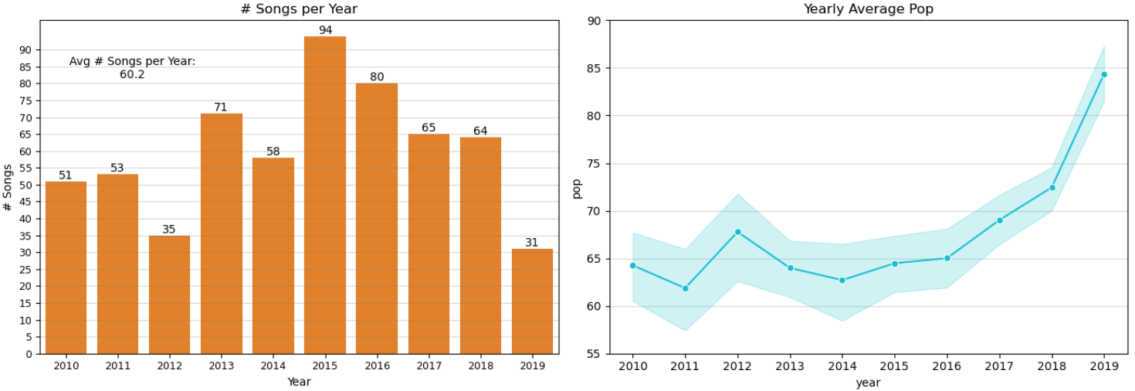
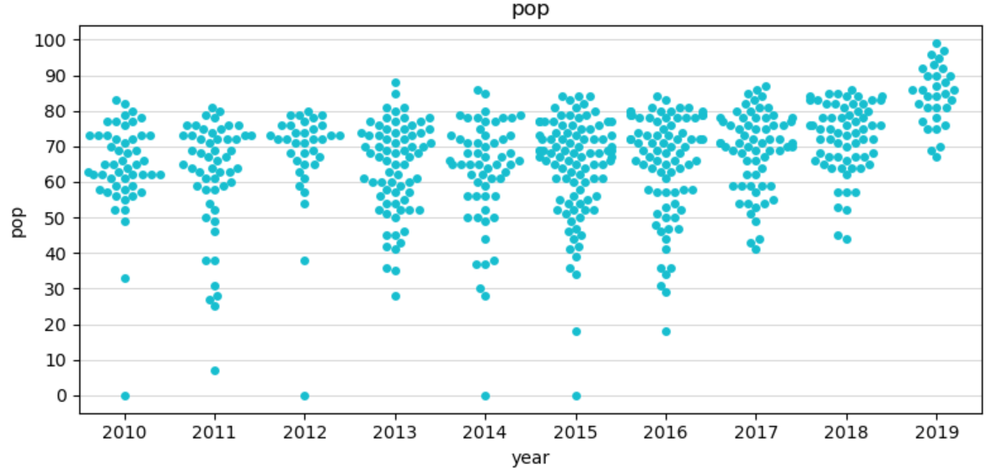
When analyzing 'pop' per subsets of the data, the most ideal data to use is that which is the most representative. The first plot above indicates that the most representative data would be between 2013 & 2018. 2012 & 2019 are the least representative years because they accounted for the fewest songs in the dataset. Using the second plot, the mean 'pop' is the greatest & increases after 2016, so 2017-2019 is the most appealing range of the data; however, the number of songs in 2019 is significantly small, & so 2019 music is not as representative as in 2017 & 2018. In the third plot, the swarmplot also supports these aforementioned findings. The high averages seen in 2017-2019 are partially due to the fact that there are no small 'pop' values unlike in previous years (excluding 2013); 2017-2019 are the only years in which there were no 'pop' values below 40.
As such, 2017 & 2018 were deemed as the best years to analyze for the most popular music, but the other years should still be analyzed, particularly 2019 because it contains the most recent data.
Correlation heatmaps were made to see what numerical values were important for popular songs. Such heatmaps were made for the entire dataset & for yearly data to help in analyzing how the parameters changed over time in respect to 'pop'.
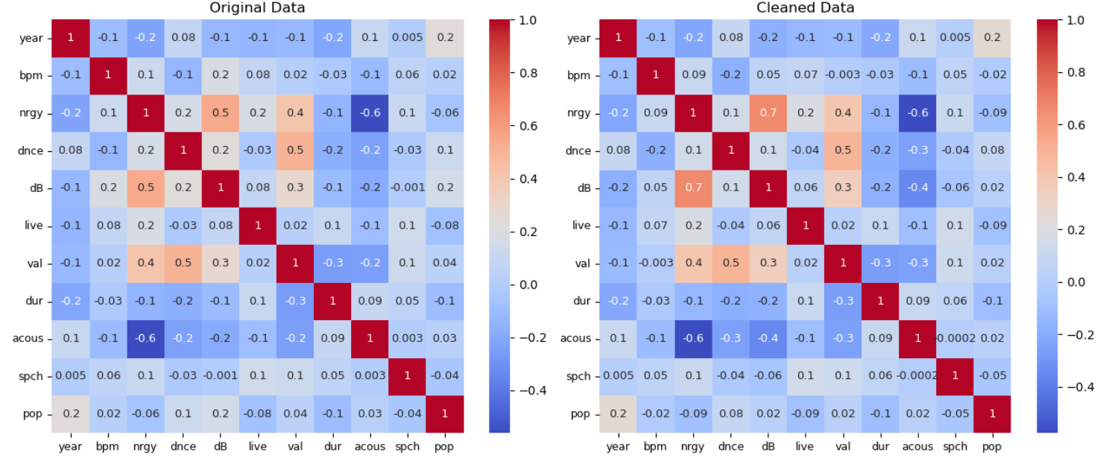
The two heatmaps above (from left to right) represent the original data & the cleaned data respectively. Recall that the only differences between the original data & the cleaned data is that one duplicate of the song "Sugar" was dropped, the 'pop' of the song "Sugar" was changed, & that multiple parameters of the song "Million Years Ago" were changed. In referencing the interpretations of correlation coefficients as suggested by the NIH, there are no non-negligible relationships in either heatmap. The relationship with 'pop' that has the most significant correlation in either dataset is 'dur' (-0.1) – 'dnce' also has a correlation of 0.1 with 'pop' in the original dataset. Additional heatmaps were made for each year's worth of data because these two heatmaps don't provide enough information to help assist in the analysis of this section. Heatmaps displaying correlation coefficients for the most recent years of data (2016-2019) are shown below.
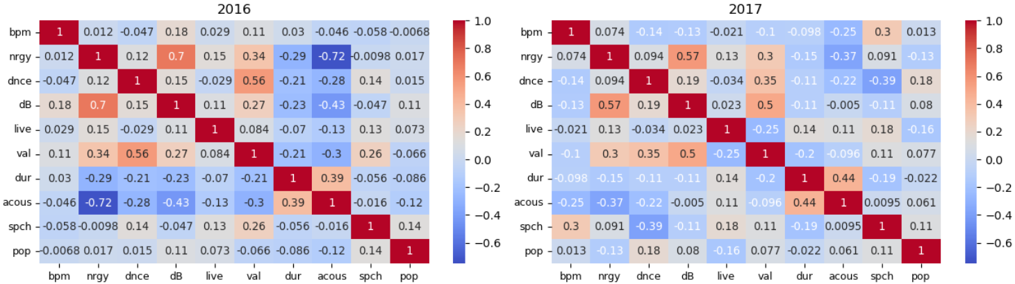
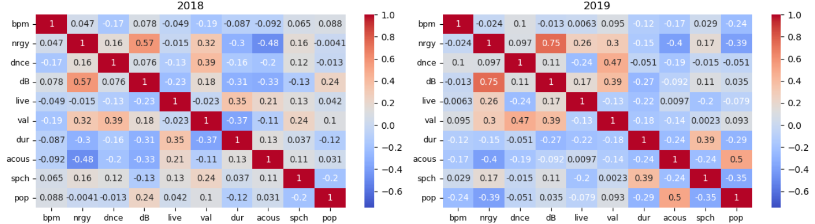
In breaking the data down by year, more information can be gleaned than in the previous heatmaps. Not only are some of the correlation coefficients larger in these yearly heatmaps than the previous two, but these relationships of 'pop' can be analyzed over time to help determine how each parameter of popular music is changing. In turn, this will help in projecting how these parameters of popular music may behave when projecting such music in the future.
Recall that the most important data to analyze for the purposes of this analysis is from 2017-2019 with slightly more emphasis on 2017 & 2018. Unfortunately, though some yearly coefficients are larger in magnitude, many still constitute non-negligible relationships. To help visualize the changes in these yearly correlation values, a plot was made which displays the relationships of each parameter with 'pop' across each year. There are nine different parameters, one line for each.
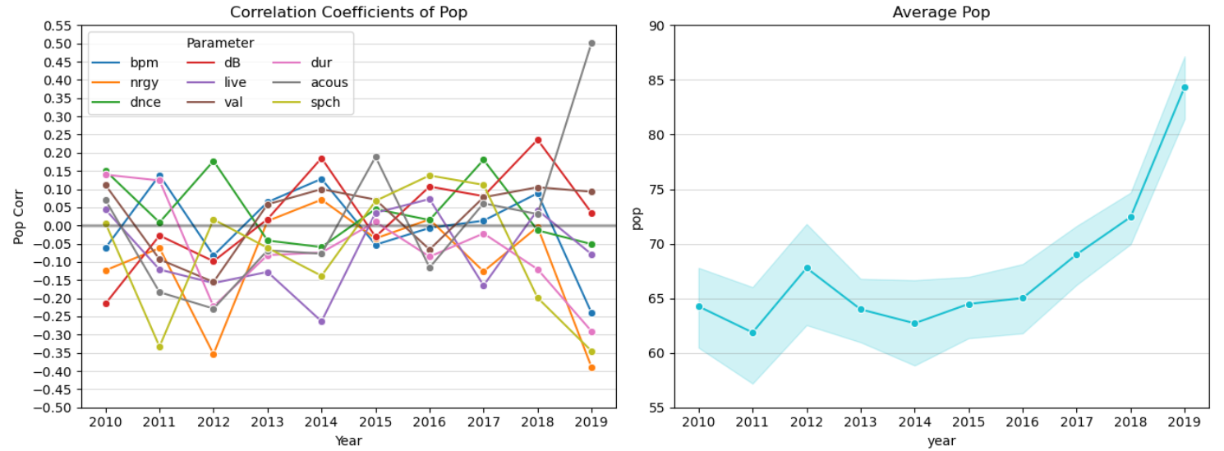
The NIH states that values of a magnitude smaller than 0.3 constitute a non-negligible relationship. From the first plot above, there are only five (of 90 total) instances in which the magnitude of the correlation was greater than 0.30 (four negative, one positive). The second plot, also shown previously, displays the average 'pop' in each year along with a confidence interval which spans 95% of the individual yearly 'pop' values.
Regarding positive relationships with 'pop,' there was only one instance in which the correlation coefficient was non-negligible; the relationship between 'acous' & 'pop' was ~0.502 in 2019, which is moderately positive according to the NIH. There was only one other instance in which the correlation coefficient was greater than 0.20; 'dB' & 'pop' had a correlation of ~0.235 in 2018, which constitutes a positive, negligible relationship. As such, the only positive relationship of 'pop' of note is with 'acous' in 2019.
Regarding negative relationships with 'pop,' there are a few non-negligible, noteworthy relationships; there are ten total correlations with 'pop' that were less than -0.20. There were four non-negligible negative correlations with pop: 'nrgy' & 'pop' (~ -0.390) in 2019, 'nrgy' & 'pop' (~ -0.353) in 2012, 'spch' & 'pop' (~ -0.345) in 2019, & 'spch' & 'pop' (~ -0.333) in 2011. Interestingly, three of these four relationships occurred in 2012 & 2019 which were the two years that had significantly fewer songs than any other. Though there were only four fewer songs in 2019 than in 2012, the standard deviation of 'pop' was greatest in 2012 & smallest in 2019, so these relationships & statistics are more credible in 2019 than in 2012.
If artists were to take recent trends into greater account than data from longer ago, the relationships mentioned above that were in 2019 would be valuable. Therefore, up-and-coming artists should make music that is more acoustic, has lower energy levels, & has less lyrics/words (smaller 'spch') to have the best chance for their music to be more popular.
When analyzing correlations & relationships with 'pop,' they can be analyzed in a yearly basis. An analysis over time, especially one pertaining to more recent data, could provide additional insights for current artists wanting to produce popular music in the near future. Across many of the parameters, they may have similar trends with 'pop' in the first couple of years, but they then reverse for the next few years, & sometimes even swap again. As 'pop' increased yearly from 2017-2019, 'dnce' also increased, whereas 'bpm,' 'nrgy,' 'dB,' 'dur,' & 'spch' all decreased; however, these trends don't always line up with their corresponding correlation coefficients. More details on the correlation between each parameter & pop are listed & described in the notebook of the project.
In summary, the parameters that had notable relationships (from strongest to weakest) with 'pop' are 'nrgy,' 'spch,' 'dur,' & 'acous.' Specifically from 2017-2019, the relationships with 'pop' (from strongest to weakest) are 'acous,' 'nrgy,' 'spch,' & 'dur.' 'Nrgy,' 'dur,' & 'spch' had negative relationships with 'pop,' whereas 'acous' had a positive relationship with 'pop.'
Music of Most Popular Artists & Genres
From a previous section of analysis in the project, the most popular artists & genres were identified. These artists & genres were used in the Analysis IV section of the project as a filter to select some of the most popular music in the dataset. Ultimately, the union of the music of these artists & genres was used for further analysis; the songs corresponding to either the artists & genres at hand. There were 133 songs that made up this filtered dataset. Though this dataset accounted for the most popular artists & genres, it did not eliminate all songs that were less popular. As such, a filter for 'pop' was applied. Specifically, songs with a 'pop' value of at least 65 were selected. This reduced the number of songs from 133 to 127. A heatmap with correlations of parameters of this data was made & compared to the heatmap using the original, cleaned dataset, previously shown. These two heatmaps are directly below.
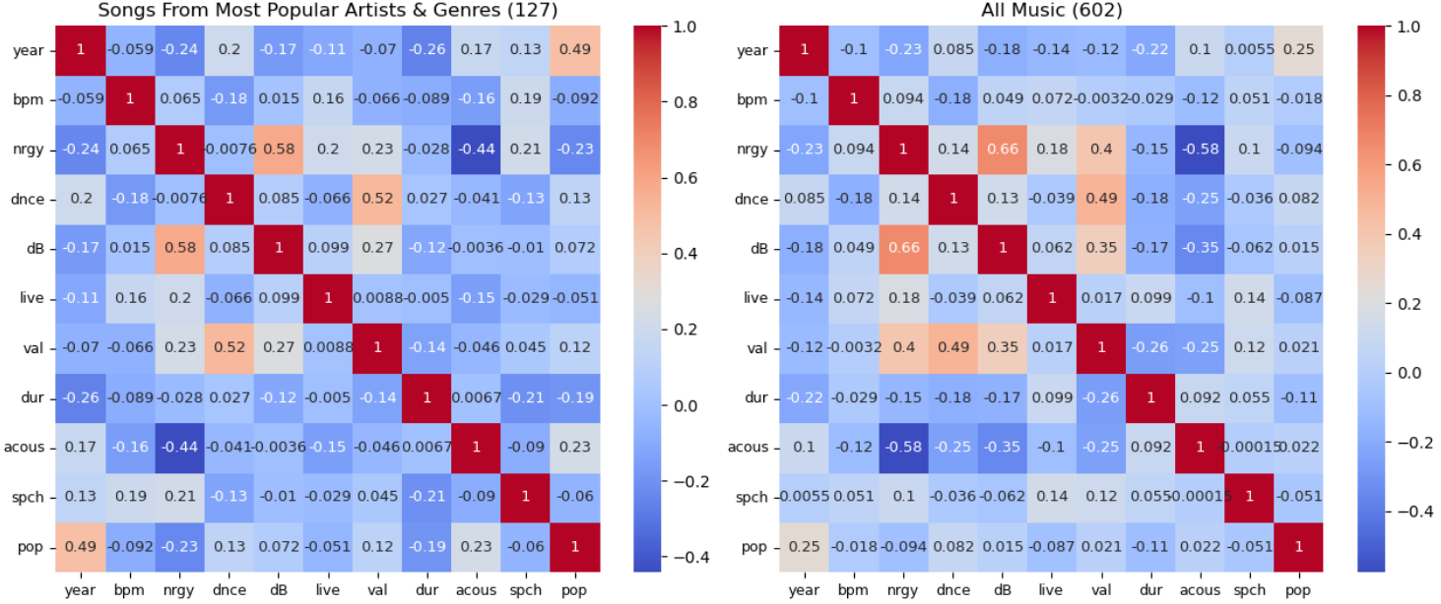
Looking at the first heatmap above, based on the NIH's guidelines for correlation coefficients, there aren't any non-negligible relationships for 'pop' except for 'year,' which indicates a clear upward trend in 'pop' over time as previously determined. On the other hand, when comparing these two heatmaps, every relationship with 'pop' excluding 'val' strengthened in magnitude from the filtered, smaller dataset. This suggests that this approach of filtering for the most popular music & setting a lower limit on the 'pop' parameter is bearing some fruit, though some more tweaking may be needed to get a more concrete understanding of how the other parameters relate to 'pop.'
Duplicated Songs
An additional method of analysis that was utilized involved analyzing data of the artists who had duplicate songs. These songs were useful to look at because these songs were popular enough that they made the Billboard in two separate years. There were 15 such songs that had a duplicate in the dataset. Seven of these 15 duplicated songs were among the 133 songs accounting for the music of the most popular artists & genres listed in Analysis I. These seven songs had an average 'pop' of ~75.29, & their 'pop' values ranged from 68-84. A heatmap of the correlations from these 30 songs is shown below.
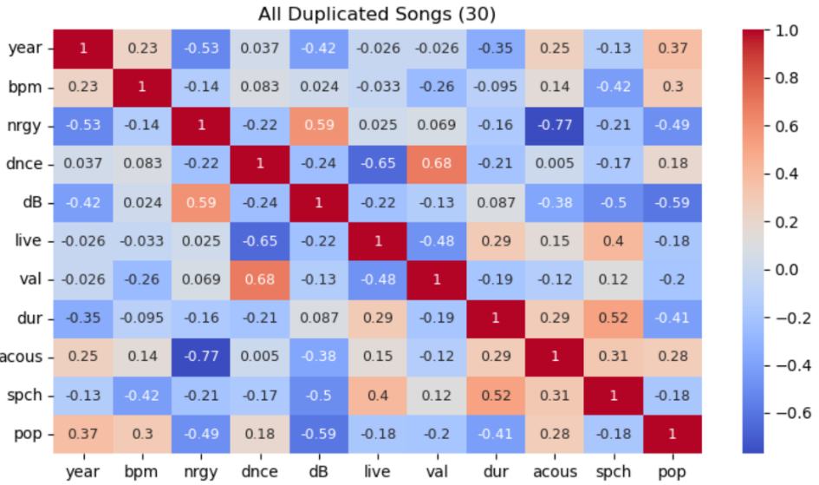
With only 15 songs, correlations are much less diluted & the values are significantly larger & more volatile in magnitude. In referring to the NIH's guidelines for correlation coefficients, there are several variables that have non-negligible relationships with 'pop' based on these 15 songs. The only moderate relationship that 'pop' had was with 'dB' (-0.59). So, songs that are quieter or softer (a more negative 'dB' value) are more popular. Relationships with a low correlation include 'bpm' & 'pop' (0.30), 'nrgy' & 'pop' (-0.49), & 'dur' & 'pop' (-0.41). Therefore, songs that have a greater tempo, lower energy, or are shorter in duration are more popular. The remaining relationships with 'pop' had negligible correlations, but they are not totally insignificant; the other five relationships had correlation coefficients with a magnitude between 0.18-0.28.
Compile Results of The Analyses
At this point, the findings from each of the analyses were compiled. This included conclusions of analyses from the most recent data (2017-2019), of yearly correlations between 'pop' & other numerical parameters for all of the data & music of the most popular artists & genres, & of the duplicated songs. The results of each of these analyses are also described in the notebook.
There were multiple instances in which these separate analyses came to similar conclusions. There was clearly some positive relationship between 'acous' & 'pop,' whereas there were clearly negative relationships between 'nrgy' & 'pop,' 'spch' & 'pop,' & 'dur' & 'pop.' There was also some evidence suggesting there is some positive relationship between 'bpm' & 'pop,' & some negative relationship between 'dB' & 'pop.'
In totality, the results of analysis would encourage aspiring artists wanting to make popular music that incorporates higher acoustic values, faster tempos, less energy, less lyrics/words, smaller lengths, & less loudness than the typical values seen of music in the data into their songs. The greatest emphasis of these qualities is on higher acoustic values, lower energy values, & shorter songs.
Quantifying the Analyses' Results & Producing Projections for Recommendations
With the results of all these analyses in mind, the third & final objective could be handled. More specifically, values of parameters could be calculated & projected in order to construct recommendations for the aspiring musician wanting to create their own popular music. As stated previously throughout the report, the most relevant data for these projections is from 2017, 2018, & 2019. Before applying the method of percentage change, a cutoff value of 70 was applied to 'pop.' This reduced the number of songs to 109. Using the same process described in the "Analysis" section of this report, averages were calculated & used to help create projections for each parameter. Averages were calculated for 2017, 2018, & 2019, & projections were made for 2020 through 2024. Reference the variable "df_predictii" to see these values.
The projections are likely to be more representative & credible for the earlier years in the resulting dataset (i.e. 2020, 2021) than later years because the music industry will more than likely evolve more & more as time goes on, thus leading to potential changes across these parameters. These projections don't have any way of tracking changes in trends of the parameters over time because it uses an average percentage change to calculate future values.
Additionally, non-numerical parameters need to be determined, specifically the genre. As prefaced in the "Analysis" section, some aggregate statistics of 'pop' were calculated for each genre some of which are shown below. From these statistics of genres with a 'pop' value of at least 70, only five genres had at least four songs; four genres had at least seven songs. Four of these five genres were of the "pop" subset (pop, dance pop, electropop, canadian pop, & edm), so the general "pop"-based subset of genres would be the most ideal for aspiring artists. Genres with more songs should be recommended over other genres because their music is more representative of the overall dataset & they've contributed more songs to the Billboard, which implies that they have produced more songs that the Billboard has deemed popular.
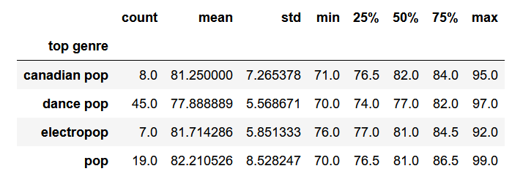
Based on the summary statistics calculated & shown above for these four pop-based genres, the "pop" genre is the most appealing. This genre accounts for the second most songs of these genres, has the largest average 'pop' value, & has the largest maximum 'pop' value. From this information, the "pop" genre was the most ideal genre, but additional analysis of these genres was conducted to gather further support & credibility. The average values & projections were merged into the variable "df_base_stats_pop_proj."
The next piece of analysis regarding genres involved determining which of these four genres best aligned with the projected values. On a separate Excel spreadsheet, values of each genre were predicted for 2020. A measure of best fit was determined by calculating the differences between the projected values for 2020 & the projected means for 2020 of each genre, then finding the sum, average, & standard deviation of these differences ("diff") for the group of genres & each (absolute values were used to find these values as magnitudes). The results of this analysis are in the Excel spreadsheet snippet shown below.
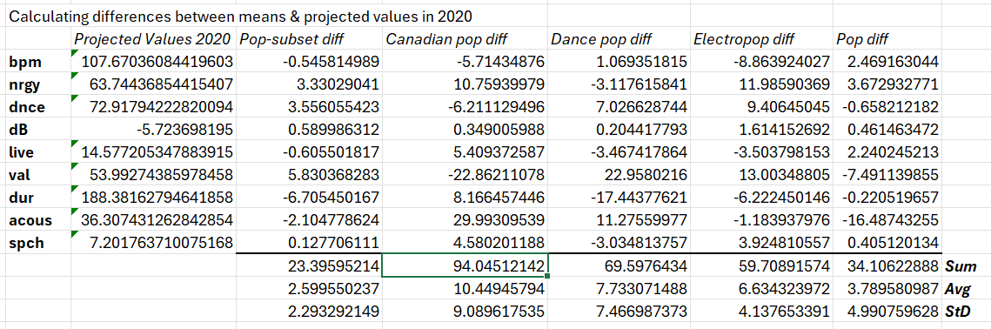
This analysis concluded that the subset of the four "pop" genres best fit the projected averages for 2020. Of the four genres individually, the best fit was the "pop" genre. Ignoring the subset of the four pop genres, the "pop" genre had the smallest sum & average differences, & the second smallest variance (standard deviation) of the four individual genres. The "electropop" genre was the only other individual genre whose aggregate differences were competitive with those of the "pop" genre (electropop had a smaller variance of the differences). Otherwise, the differences of "pop" were considerably smaller than any other individual genre.
With these results in combination with the statistics of these genres shown previously, there was a strong indication that "pop" was the most fitting of the four genres in relation to the projections. As such, the aspiring artist would be advised to make a song in the "pop" genre.
In looking at the actual data in 2019 & the projected data in 2020, most parameters exhibited slight changes & others experienced considerable changes. Only 'dur,' 'acous,' & 'spch' exhibited changes of more than five percent, & only 'acous' experienced a change of more than 15 percent. The significant change in 'acous' was heavily influenced by the large, sudden increase in 'acous' from 2018-2019. As such, 'acous' may be a variable in which artists don't necessarily need to use such volatile or large values as suggested by the projections. 'Spch' is another variable that allows some discretion to the artist during its currently decreasing trend. For a parameter whose average (across the entire 602 songs) is ~8.38, the projected value is estimated to be half of this within five years (in 2024). As such, artists can use a wider range of values when it comes to the 'spch' parameter.
Regarding the other parameters (excluding 'live'), the artists should stick closer to the recommended values because of the smaller changes in these parameters between the actual & projected averages. When it comes to the 'live' parameter, the averages are certainly useful to look at, but ultimately it is up to the discretion of the artist whether or not they would prefer to play their song in front of a live audience.
In summary, using the results of the quantitative analyses above, an aspiring artist is advised to make songs in the "pop" genre. Unfortunately, since the dataset does not specify as to how these parameters are measured/quantified, there is no way for this report to describe how to apply the values of these characteristics in a song. The recommended values for each parameter between 2020 & 2024 as provided by the projections are shown below.
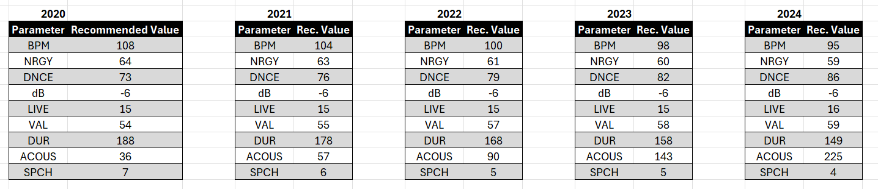

Conclusions
Recall the goals of the project. The primary objectives included:
- Identify how the parameters in the data relate to a song's popularity – quantified in the dataset via the 'pop' parameter.
- Identify the most popular music in the dataset & analyze how the parameters of this music relate to these songs' popularity.
- Determine values for each of the parameters of a song based on the analyses of these parameters for the most popular music. These values will be used as recommendations for the aspiring artist to use to create their own music in the hopes that it will be popular (or a "hit").
In this analysis, qualitative techniques such as heatmaps were used to analyze the different parameters in relation to the target variable 'pop.' Multiple filters were applied to get a better understanding of how the parameters' relationships with 'pop' changed for different subsets of data (music). The method of percentage change was used to calculate averages & create projections based on the results of the qualitative analyses. Other statistical calculations used throughout the analysis included correlations, averages, variance, & counts.
Regarding the analyses of the relationships between the parameters & 'pop,' they had some similar conclusions. Specifically, there was clearly some positive relationship between 'acous' & 'pop,' whereas there were clearly negative relationships between 'nrgy' & 'pop,' 'spch' & 'pop,' & 'dur' & 'pop.' There was also some evidence suggesting there is some positive relationship between 'bpm' & 'pop,' & some negative relationship between 'dB' & 'pop.'
In totality, the results of analysis would encourage aspiring artists wanting to make popular music that incorporates higher acoustic values, faster tempos, less energy, less lyrics/words, smaller lengths, & less loudness than the typical values seen of music in the data into their songs. The greatest emphasis of these qualities is on higher acoustic values, lower energy values, & shorter songs.
As the analysis switched from a qualitative to a quantitative approach, multiple filters were applied to the data that was used for the purposes of creating projections. The dataset was condensed to only include the most recent music (from 2017 through 2019) & for songs with a popularity ('pop') of at least 70 – this subset accounted for 109 of the 602 total songs. Using the concept of percentage change, averages were calculated to help construct projections for future values of parameters. Summary statistics & calculations done in an Excel spreadsheet were used to determine the most appropriate genre to accompany the projections of the numerical parameters.
The projections spanned the immediate five years following the music in the dataset (2020-2024). Emphasis was placed on the fact that the credibility & representativeness of the projections would decline as more time passed. Unfortunately, since the dataset does not specify as to how these parameters are measured/quantified, there is no way for this report to describe how to apply the values of these characteristics in a song. The recommended values for each parameter between 2020 & 2024 as provided by the projections are shown on the page prior in the "Results" section.
Once more, these projections are simply recommendations. Some parameters are allowed more leeway than others, but the values are ultimately up to the artist's discretion.

Additional Notes
In the python notebook, the relevant analysis is in the "Analysis IV" section which starts at about two-thirds of the way into the notebook of the project.
This link contains the source of the dataset. The python notebook is contained & accessible in the folder which also contains this Word document. The python notebook is an HTML file titled "Python Notebook – Spotify Music Data."

Citations
1.6. Nearest Neighbors. Scikit Learn. (n.d.). https://scikit-learn.org/stable/modules/neighbors.html#classification. Accessed 2024, May 28.
Google. (n.d.). Billboard. Google. https://www.google.com/search?client=firefox-b-1-d&q=the%2Bbillboard. Accessed 2024, May 28.
K-Nearest Neighbor(KNN) algorithm. GeeksforGeeks. (2024, January 25). https://www.geeksforgeeks.org/k-nearest-neighbours/. Accessed 2024, May 28.
Mukaka, M. (2012, September 24). A guide to appropriate use of Correlation coefficient in medical research. National Library of Medicine. https://www.ncbi.nlm.nih.gov/pmc/articles/PMC3576830/. Accessed 2024, May 28.
Organize Your Music. Spotify. (n.d.). http://organizeyourmusic.playlistmachinery.com/#. Accessed 2024, May 28.

